Paul Kafka

Embedded System Design

11/5/13

Term Research Project

Project Title: LCD

Task: “Program to implement custom character like different smiley faces.”

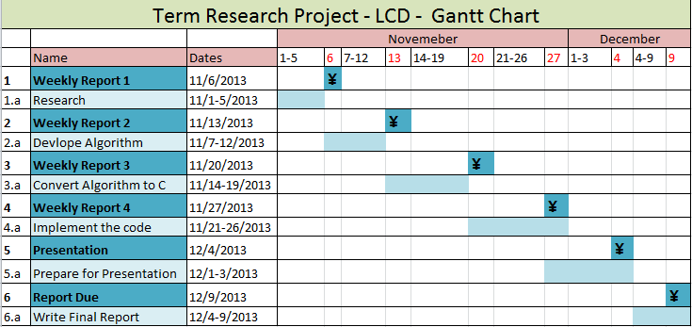

LCD Panel has 16 chars per 2 lines

Researched the SOPC builder documentations from the altera university IP blocks.

Wrote a c program that uses acii characters to make smilie faces.

Going to Using the predefined Media uP with the Altera Monitor Program.

Weekly reports

Summary of the tasks from the gant chart.

Indicate the status of project: on schedule, behing, or ahead.

11-6,11-13,-11-20-11-27 weekly status reports

Presentation Wednesday 12-4@10.45AM: LCD by Paul Kafka

Final report due dec 9

¥